England has never been known for its majestic mountain ranges, or for its epic year-round snowfall. Nor are the British public known for their expertise in, and enthusiasm for, snow sports such as skiing, slalom, bobsleigh, skeleton or snowboarding. How then, did an English athlete manage to demonstrate a Gold-medal winning performance in the Skeleton event that claimed victory over all of the other great snow sports nations such as Austria, Switzerland, Canada and the US?

History of Winter Sports in England
There is a delightful David and Goliath-esque quality to UK victories at the Winter Olympics. Why? Because usually great Winter Olympics victories are achieved by athletes who grew up on the slopes, in nations where beautiful mountain ranges, clean white slopes, top Winter sports coaches and Winter sports facilities are de rigeur. It comes as no surprise to the average Brit that our Winter Olympian and Paralympian hopefuls have a dearth of facilities and only piddly rain, grey skies, flat land and unpredictable snowfall to help them on their way to a coveted podium place. It cannot be said that the British lack any kind of Olympic spirit but, given these conditions, it would seem unlikely that such indomitable spirit could ever result in acquisition of an Olympic or Paralympic medal.

This was to change in 2001, when a bobsleigh was first ridden down a custom-made 125m push start track at the English Institute of Sport (part of the UK Sports Institute Network) at Bath University; our first and only push start track in England. The track was installed, at a cost of £300,000, in time for training to take place for the 2002 Salt Lake City Winter Olympics, and our athletes have since continued the training for Turin and Vancouver in the disciplines of bobsleigh, luge and skeleton. The track was developed over a three-year period as a result of a partnership between the EIS, the British Bobsleigh Association, Sport England’s lottery fund and sponsors VT Aerospace.
Image created by David Boyle and reproduced under a Creative Commons licence.

BBA Performance Director Tony Wallington commented that "The start is crucial in bobsleigh and this track mirrors the real thing...Using its 14 'eyes', we can analyse velocity and calculate the optimum distance we should be running at the start in Salt Lake..."But it will also help identify talent for the future. Once people have been down this and experienced that unique exhilaration for the first time, they will want more."

Wallington was completely on the mark with this statement, as Amy Williams, Gold medallist at the recent Vancouver 2010 Winter Games, was introduced to the sport of skeleton as a result of watching friends train at the track. From her first experience at the Bath facility, she was hooked.

Wallington was also to state that "Ice-track sports are coming back into their own in this country...We lost the expertise for a while but this track can help us back to the top level."
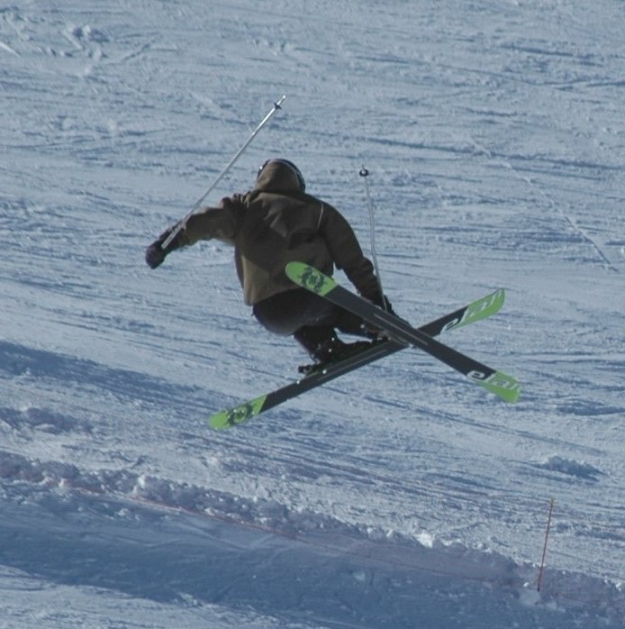
Image created by Marc Lacoste and reproduced under a Creative Commons licence.

Salt Lake City Victories
Alex Coomber of Team GB went on to subsequently capitalise on training at the Bath push start track to secure a Bronze medal in the Skeleton bobsleigh event at Salt Lake City. In Bath, a young athlete named Amy Williams would remember watching Coomber on television; her introduction to the sport. Three months later, Williams was, purely by chance, to gain her first personal introduction to the sport.

“I got into it purely from living in Bath, training at the university and seeing the push-start facilities there,” Williams said. “I tagged along with some of the guys who were training at the time and had a go. They were going to the World Push Start Championships, in Holland, and I went along for a bit of a giggle. Simon Timson (Britain’s performance director) was there and I ended up winning the guest class.” The track at Bath mimics the starting conditions of the Skeleton event but is not a full track, which made her subsequent victories all the more impressive.

Williams took only three seasons to become a Winter sport Silver medallist at the World Junior Championships. She was already an athlete, with major ambition, but was cogent of the fact that she would never make the Olympics in her chosen discipline. As an athletics competitor, she knew that the level of talent and ambition in the country at the time would probably make Olympic qualification too difficult. Her experience on the push start track, coupled with the encouragement of Timson, pushed Amy to switch to a Sports Development degree at Bath University so she could locate close to the facility to train.

Vancouver 2010 Triumph
Amy Williams was to go on and win a historic Gold medal in the Vancouver Winter Olympics 2010 in the Women’s Skeleton event; the first British solo Gold for 30 years, and the first female Winter Olympic Gold since 1952. Even more impressively she won by breaking her own track record. Shelley Rudman of Team GB was to also achieve a 6th place. Williams’ victory was to be fiercely contested by the Canadians and Team USA, who lodged a complaint against the helmet worn by Williams (the complaint was, however, rejected).
Her achievement is all the more remarkable as Britain does not have a full skeleton track to train on, apart from a dry starting section near Bath.

The Future of Winter Sport
So what does the future hold for British Winter sport? No doubt we will find out in Sochi in 2014!

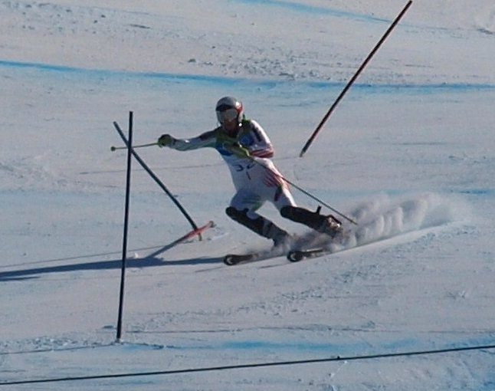
Image created by Jon Wick and reproduced under a Creative Commons licence.

START THE DISCUSSION
- Investigate the winter sports provisions in the countries that top the Olympic medal table. Which countries are these and how much money do they spend in developing their athletes?
- How many Winter sports are there?
- How do you think we will fare in Sochi?

FIND OUT MORE
Vancouver Winter Olympics 2010: Profile of Great Britain
http://www.nbcolympics.com/nations/nation=gbr/olympic-tradition.html
Team GB Vancouver 2010
http://vancouver2010.teamgb.com/

CREDITS
© Oxford Brookes University 2010. oxb:060111:031dd

This resource was produced as part of the 2012 Learning Legacies Project managed by the HEA Hospitality, Leisure, Sport and Tourism Subject Centre at Oxford Brookes University and was released as an Open Educational Resource. The project was funded by HEFCE and part of the JISC/HE Academy UKOER programme. Except where otherwise noted above and below, this work is released under a Creative Commons Attribution only licence.

Exceptions to the Licence
The name of Oxford Brookes University and the Oxford Brookes University logo are the name and registered marks of Oxford Brookes University. To the fullest extent permitted by law Oxford Brookes University reserves all its rights in its name and marks, which may not be used except with its written permission.

The JISC logo is licensed under the terms of the Creative Commons Attribution-Non-Commercial-No Derivative Works 2.0 UK: England & Wales Licence. All reproductions must comply with the terms of that licence.

The Higher Education Academy logo and the HEA Hospitality, Leisure, Sport and Tourism Subject Centre logo are owned by the Higher Education Academy Limited and may be freely distributed and copied for educational purposes only, provided that appropriate acknowledgement is given to the Higher Education Academy as the copyright holder and original publisher.



Reusing this work
To refer to or reuse parts of this work please include the copyright notice above including the serial number. The only exception is if you intend to only reuse a part of the work with its own specific copyright notice, in which case cite that.

If you create a new piece of work based on the original (at least in part), it will help other users to find your work if you modify and reuse this serial number. When you reuse this work, edit the serial number by choosing 3 letters to start (your initials or institutional code are good examples), change the date section (between the colons) to your creation date in ddmmyy format and retain the last 5 digits from the original serial number. Make the new serial number your copyright declaration or add it to an existing one, e.g. ‘abc:101011:031dd’.

If you create a new piece of work or do not wish to link a new work with any existing materials contained within, a new code should be created. Choose your own 3-letter code, add the creation date and search as below on Google with a plus sign at the start, e.g. ‘+tom:030504’. If nothing comes back citing this code then add a new 5-letter code of your choice to the end, e.g.; ‘:01lex’, and do a final search for the whole code. If the search returns a positive result, make up a new 5-letter code and try again. Add the new code your copyright declaration or add it to an existing one.

